CAR AND DRIVER
TEXTING WHILE DRIVING
How Dangerous Is It?
BY MICHAEL AUSTIN, June 2009

exting is on the rise, up from 9.8 billion messages a month in December '05 to 110.4 billion in December '08. Undoubtedly, more than a few of those messages are being sent by people driving cars. Is texting while driving a dangerous idea? We decided to conduct a test. Previous academic studies-much more scientific than ours-conducted in vehicle simulators have shown that texting while driving impairs the driver's abilities. But as far as we know, no study has been conducted in a real vehicle that is being driven.
T
1

To keep things simple, we would focus solely on the driver's reaction times to a light mounted on the windshield at eye level, meant to simulate a lead car's brake lights. Wary of the potential damage to man and machine, all of the driving would be done in a straight line. We rented the taxiway of the Oscoda-Wurtsmith Airport in Oscoda, Michigan. Given the prevalence of the Black-Berry, the iPhone, and other text-friendly mobile phones, the test subjects would have devices with full "qwerty" keypads and would be using text-messaging phones familiar to them. Intern Jordan Brown, 22, armed with an iPhone, would represent the younger crowd. The older demographic would be covered by head honcho Eddie Alterman, 37, using a Samsung Alias.
2

Our Honda Pilot (four-wheel-drive SUV)
served as the test vehicle. When the red light
on the windshield lit up, the driver was to hit the brakes. The author, riding shotgun,
would use a hand-held switch to trigger the
red light and monitor the driver's results.
Each trial would have the driver respond five times to the light, and the slowest reaction
3
3

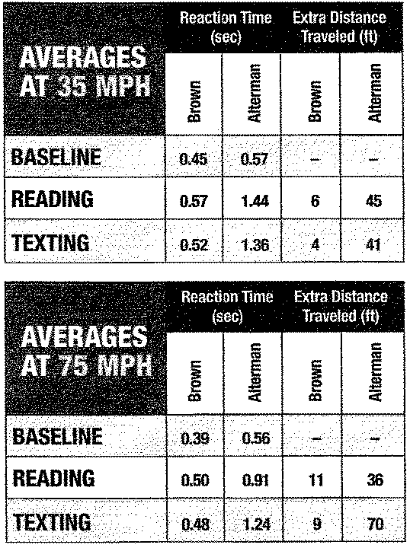
time (the amount of time between the acti-
vation of the light and the driver hitting the
brakes) was dropped.
3

First, we tested both drivers' reaction times at 35 mph and 70 mph to get baseline readings. Then we repeated the driving procedure while they read a text message aloud (a series of Caddyshack quotes). This was followed by a trial with the drivers typing the same message they had just received. Both of our lab rats were instructed to use their phones exactly as they would on a public road. The results, though not surprising, were eye-opening. Intern Brown's baseline reaction time at 35 mph of 0.45 second worsened to 0.57 while reading a text, and improved to 0.52 while writing a text. At 70 mph, his baseline reaction was 0.39 second, while the
reading (0.50) and texting (0.48), numbers
4
5
continues on next page


TEXTING WHILE DRIVING
continued from previous page

were similar. But the averages don't tell the whole story. Looking at Brown's slowest reaction time at 35 mph, he traveled an extra 21 feet (more than a car length) before hitting the brakes while reading and went 16 feet longer while texting. At 70 mph, a vehicle travels 103 feet every second, and Brown's worst reaction time while reading at that speed put him about 30 feet (31 while typing) farther down the road.
5

on-the-phone technique resulted in some serious lane drifting.

The prognosis doesn't improve when you look at the limitations of our test. We were using a straight road without any traffic, road signals, or pedestrians, and we were only looking at reaction times. Even though our young driver fared better than the balding Alterman, Brown's method of holding the phone up above the dashboard and typing
8

The key element to driving safely
is keeping your eyes .and your mind on the road.
Text messaging distracts any driver from that
primary task.
with one hand would make it difficult to do anything except hit the brakes. And if anything in the
periphery required a response, well,

Alterman fared much, much worse. While reading a text and driving at 35 mph, his average baseline reaction time of 0.57 second nearly tripled, to 1.44 seconds. While texting, his response time was 1.36 seconds. These figures correspond to an extra 45 and 41 feet, respectively, before hitting the brakes. The results at 70 rnph were similar: Alterman's response time while reading a text was 0.35 second longer than his base performance of 0.56 second, and writing a text added 0.68 second to his reaction time.
6

As with the younger driver, Alterman's
slowest reaction times were a grim
7
scenario. He went more than four seconds
before looking up while reading a text
message at 35 mph and over three and a half seconds while texting at 70 mph. Even in the best of his bad reaction times while reading or texting, Alterman traveled an extra 90 feet past his baseline performance; in the worst case, he went 319 feet farther
down the road. Moreover, his two-hands-
both drivers would probably be unable to react.

Both socially and legally, drunk driving is completely unacceptable. Texting, on the other hand, is still in its formative period with respect to laws and opinion. A few jurisdictions have passed ordinances against texting while driving. But even if sweeping legislation were passed to outlaw any typing behind the wheel, it would still be difficult to enforce the law.
9

In our test, neither subject had any idea that using his phone would slow down his reaction time so much. Like most folks, they think they're pretty good drivers. Our results prove otherwise, at both city and highway speeds. The key element to driving safely is keeping your eyes and your mind on the road. Text messaging distracts any driver from that primary task. So the next time you're tempted to text, tweet, e-mail, or otherwise type while driving, either ignore the urge or pull over. We don't want you rear-ending us.
10

May be photocopied for classroom use. Texts and Lessons for Content-Area Reading by Harvey "Smokey" Daniels and Nancy
Steineke, © 2011 (portsmouth, NH: Heinemann). Reprinted with permission.

Texting While Driving – How Dangerous Is It?

1. | According to the article, texting messages increased
 |  | A. | from 9.8 billion to 110.4 billion in five years.
 |  | B. | by 100 billion in three years.
 |  | C. | from 9.8 billion to 110.4 billion in three years.
 |  | D. | by 100 billion in five years.
(detail/evidence, CC2)
2. | From the passage, one can conclude that texting while driving
 |  | E. | makes little difference in how one drives.
 |  | F. | is decreasing among drivers.
 |  | G. | can distract drivers and cause accidents.
 |  | H. | increases highway safety.
(central idea, CC2)
3. | The statement which best describes this article is
 |  | A. | a “how to” manual for texting while driving.
 |  | B. | a report describing the effects of texting while driving.
 |  | C. | a survey study of texting while driving.
 |  | D. | a report on the effect of driving while drunk.
(central idea, CC2)
4. | The word “qwerty” in paragraph 2 refers to
 |  | E. | a brake signal.
 |  | F. | an airport taxiway.
 |  | G. | a phone keypad.
 |  | H. | a car’s brake lights.
(language, CC4)
5. | One can infer from this article that
 |  | A. | the increased number of text messages generally occurs while studying.
 |  | B. | increased text messaging has resulted in increased texting while driving.
 |  | C. | text messaging helps people stay in touch with more people.
 |  | D. | text messaging does not reduce one’s ability to drive safely.
(detail/evidence, CC2)

6. | The stated reason for choosing speeds of 35 and 70 miles per hour in the study simulated
 |  | E. | testing reaction time at a slow speed and a fast speed.
 |  | F. | measuring more uniform statistical data with one speed twice as fast as the other.
 |  | G. | standard speed limit postings.
 |  | H. | city and highway speeds.
(detail/evidence, CC2)
7. | The main idea of the article is
 |  | A. | texting while driving is safe if one is careful.
 |  | B. | beware of other drivers who are texting while driving.
 |  | C. | texting while driving slows reaction time.
 |  | D. | texting while driving keeps one popular with friends.
(main idea, CC2)
8. | According to the article, the limitation of previous studies was due to
 |  | E. | using crash dummies as test subjects.
 |  | F. | using a simulator instead of a real vehicle.
 |  | G. | using an old clunker instead of a new vehicle.
 |  | H. | using only one speed instead of two different speeds.
(detail/evidence, CC2)
9. | The article originates from
 |  | A. | The survey data obtained from previous studies.
 |  | B. | The Detroit News and Free Press newspaper.
 |  | C. | Car and Drive magazine.
 |  | D. | June 2010.
(point of view, CC 6)
10. | According to the article, if one is tempted to text while driving one should,
 |  | E. | ignore the urge but drive home fast to answer the message.
 |  | F. | think of other temptations instead.
 |  | G. | ignore the urge or pull over to reply.
 |  | H. | send a brief text stating that you are driving and will reply later.
(detail/evidence, CC2)

“Texting while Driving” Answer Key

1 – C
2 – G
3 – B
4 – G
5 – B
6 - H
7 - C
8 - F
9 - C
10 - G

Possible Summary:

The braking reaction time of drivers who text while driving is put to the test in this article. (central idea, CC2) Two subjects, aged 22 (Brown) and 37 (Alterman), are put through a series of driving scenarios repeatedly at 35 miles per hour (mph) and again at 70 mph (considered standard city and highway driving speeds). (detail/evidence, CC2) Each of the drivers had to react to a red light on the windshield, which simulated the braking light of a vehicle in front of them. (detail/evidence, CC2) Reaction times while both reading a text message and sending a text message showed that it took additional time to brake when texting and showed that the vehicle traveled considerable distance before braking. (detail/evidence, CC2) Since additional factors such as traffic lights, pedestrians and curved roads were not present on the straight runway, the conclusion is that texting while driving considerably increases the chance for an accident, similar to driving drunk. (central idea, CC2)

Analysis of Craft:

This magazine article (genre, CC5) from Car and Driver is organized by thesis with evidence. (organization, CC5) The author gives statistics to summarize the results. (organization, CC5) Information is supported by bar charts giving statistical data. (organization, CC5) The author gives specific examples including the use of text-messaging phones with “qwerty” keypads, a Honda Pilot SUV, and an airport taxiway as a location. (organization, CC5) The sequential narration of the experiment assists the reader’s understanding of the conditions and results. (organization, CC5) The date of the article shows that the information is relatively up-to-date. (point of view, CC 6) The author is also the researcher. (point of view, CC 6) Metaphoric language engages the reader with phrases such as “riding shotgun,” and by referring to test drivers as “lab rats.” (language, CC4) The author uses vivid adjectives such as “grim” and “serious lane drifting.” (language, CC4)

