Your Carbon Footprint Grade 2
Angie LePetit, published by Capstone
Every step you take on a beach leaves behind a footprint. So do wet steps on a dry sidewalk or a trek through a muddy yard. Your footprints change the places that you go. But what does a carbon footprint do?
1

2

3

4

A carbon footprint doesn’t look like a foot. In fact, you can’t see it at all! But it is a mark you leave behind. A carbon footprint measures how much you change Earth by using its fossil fuel energy.
Coal, oil, and natural gas are fossil fuels. They are found deep inside Earth. They have given us energy for many years. But once we use them up, they will be gone forever.

Your Carbon Footprint
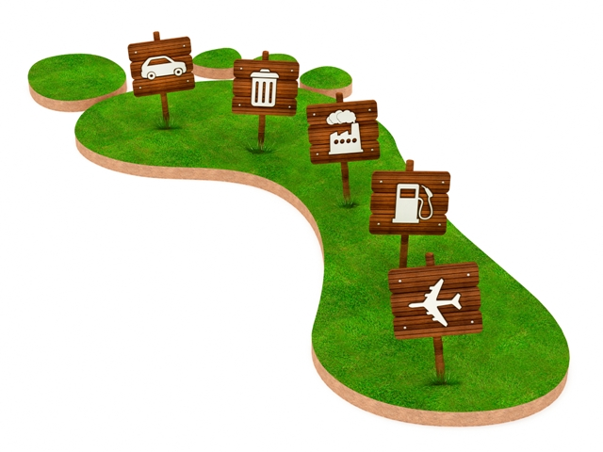

A hot, polluted planet isn’t good for anyone. That’s why we need to make good choices about our energy use. The smaller our carbon footprints, the healthier we keep Earth.

4

5

6

7

It takes energy to make stuff. An easy way to shrink your carbon footprint is to reuse things. Old socks can be made into puppets. Empty jelly jars make great piggy banks. By reusing items, we keep factories from making too much stuff. It keeps Earth clean too!
A big part of our carbon footprint comes from driving. Cars, buses, and trucks add a lot of pollution to the air. You can keep Earth cooler and cleaner by walking or riding your bike.
Lights off! You can reduce your carbon footprint by using less electricity at home. Remember to turn off lights and TVs when they’re not in use. In the summer, ask an adult if you can turn up the thermostat a few degrees. In the winter, turn it down.
Talking and Writing
After you finish your highlighting activity, talk with a partner and then with your teacher and class about the message you think the author, Angie LePetit, wants readers to understand after reading this selection. What does the author want readers to do? List three things the author thinks readers should do to reduce our carbon footprint and make Earth healthier and cooler. Reread parts of the selection to find answers.
- Reread paragraph #6.

- Reread paragraph #7.

- Reread paragraph #8.

Teachers Edition
Guided Highlighted Reading for content/summary (Close and Critical Reading Question 1) Directions: With a highlighter pen, follow the teacher’s prompts and highlight what the prompts instruct you to highlight.
The teacher reads the following:
In lines #2 and #3 of paragraph #1, find and highlight what your footprints do. (Your footprints change the places that you go.) (RI 2)
In paragraph #2, find and highlight what a carbon footprint measures. (how much you change Earth by using its fossil fuel energy) (RI 1, RI 4)
In paragraph #3, find and highlight examples of fossil fuels. (Coal, oil, and natural gas) (RI 1)
In the illustration next to #4, circle the things that use gas, a fossil fuel. (car, factory, gas pump, and airplane) (RI 5, RI 7)
In paragraph #5, find and highlight how we could keep Earth healthier. (smaller carbon footprints) (RI 2)
In paragraph #6, find and highlight what you could do to save energy and shrink your carbon footprint. (reuse things) (RI 1) Explain what the word, shrink, means – make smaller.
In paragraph #7, find and highlight what you could do to keep Earth cooler and cleaner. (walking and riding your bike (instead of riding in a car) (RI 1)
In paragraph #8, find and highlight two or three other things that you could do to reduce your carbon footprint. (turn off lights and TV’s when they are not in use and turn up (or down) the thermostat a few degrees) (RI 1)

Background Building Before Reading
Talk with students about the meaning of carbon footprint. (Your carbon footprint is the amount of carbon produced by all of the things you do. For example, producing the electricity that powers your video game may be putting carbon dioxide into the atmosphere. Carbon dioxide is given off when you ride in a gasoline-powered car. Using less energy reduces our carbon footprint and helps keep Earth healthy.) You might show students the illustration and talk about things that increase our carbon footprint. (RI 4)
Follow-up:
Talk with students about the message the author is trying to get across to readers. Ask them what they think the author’s message is for readers. Have students turn and talk with a partner. Then have them share with the class. Have students list what they could do. (reuse things, walk and ride bicycles, and turn off lights and TV when not in use) Have them give details.
Suggested Message: We must change the way we do things to reduce the amount of carbon we put into our atmosphere when we burn fossil fuels. According to most scientists, Earth’s survival and ours depends on how we change our habits to reduce our carbon footprint. (Concepts: Survival requires change to stop climate change.) (RI 6)
Writing connection or enrichment: Create a poster or a pictochart on how to shrink your carbon footprint on the topic you choose.
Possible Topics for students to choose: Recycle _______, Electricity, Water, Trash, Laundry, and Nature, Travel.

More ideas…

