Characteristics of Career and College Ready Students
Michigan  Literacy Anchor Standards | NRC Science  and Engineering  Practices | Michigan  Social Studies  HSCE-GLCE | Michigan Mathematics  Practices | Michigan Visual, Performing, and Applied Arts (VPA) Guidelines | CTE Career Ready Practices
 |  | Technology and Tools
- Integrate and evaluate content presented in diverse formats and media  - Use digital media and visual displays of data to express information; produce and publish writing, interact and collaborate with others; and gather relevant information from multiple sources | - Use mathematics, information and computer technology, and computational thinking  - Develop and use models | - Compose written, spoken, and/or multimedia compositions in a range of genres … that serve a variety of purposes  - Know how to find and organize information from a variety of sources | - Use appropriate tools strategically  - Model with mathematics | - Create preliminaries, possibilities and drafts  - Acquire knowledge and skills | - Apply appropriate academic and technical skills  - Use technology to enhance productivity
 |  | Argument and Reasoning
- Evaluate argument and claims in a text, speech, or write arguments to support claims  - Draw evidence from literary and informational texts to support analysis, reflection, and research  - Present information, findings, and supporting evidence | - Engage in argument from evidence  - Analyze and interpret data | - Present a coherent thesis when making an argument, support with evidence, articulate and answer possible objections, and present a concise, clear closing  - Write persuasive/ argumentative essays expressing and justifying decisions on public policy issues | - Construct viable arguments and critique the reasoning of others  - Reason abstractly and quantitatively | - Recognize patterns and relationships  - Questions, problems, needs, reflections, and revisions | - Consider the environmental, social and economic impacts of decisions  - Employ valid and reliable research strategies

Michigan  Literacy Anchor Standards | NRC Science  and Engineering  Practices |  | Michigan  Social Studies  HSCE-GLCE | Michigan Mathematics  Practices |  | Michigan Visual, Performing, and Applied Arts (VPA) Guidelines | CTE Career Ready Practices
 |  |  | Communication and Collaboration
- Effectively converse and collaborate with diverse partners  - Use language to comprehend more fully when reading or listening  - Produce clear and coherent writing |  | - Obtain, evaluate, and communicate information | - Develop and refine a position, claim… that will be explored and supported by analyzing different perspectives  - Deeply examine policy issues in group discussions and debates (clarify issues, consider opposing views, apply democratic values or constitutional principles, anticipate consequences) to make reasoned and informed decisions |  | - Attend to precision | - Exhibit, perform, present, or publish  - Apply techniques and skills to communicate |  | - Act as a responsible and contributing citizen and employee  - Communicate clearly, effectively and with reason  - Model integrity, ethical leadership and effective management  - Work productively in teams while using cultural/global competence
 |  |  | Problem Solving
- Integrate multiple sources of information in order to make informed decisions and solve problems  - Conduct research projects |  | - Ask questions (science) and define problems (engineering)  - Plan and carry out investigations  - Construct explanations (science) and design solutions (engineering) | - Clearly state an issue as a question of public policy; trace the origins of an issue; analyze various perspectives; and generate and evaluate possible alternative resolutions  - Use deductive and inductive problem-solving skills as appropriate to the problem being studied |  | - Make sense of problems and persevere in solving them  - Look for and make sense of structure  - Look for and express regularity in repeated reasoning | - Present art, products, or solutions  - Problem solve, make critical decisions, and edits  - Experiment and search out problems |  | - Attend to personal health and financial well-being  - Demonstrate creativity and innovation  - Utilize critical thinking to make sense of problems and persevere in solving them  - Plan education and career path aligned to personal goals

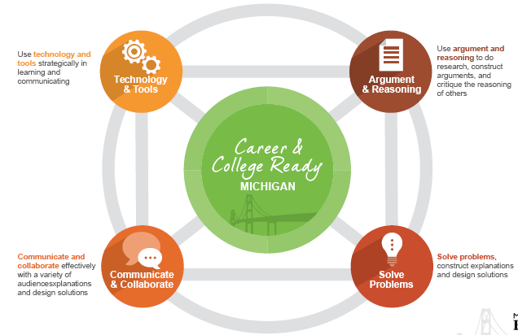

Career and College Ready Students…

- use technology and tools strategically in learning and communicating,

- use argument and reasoning to do research, construct arguments, and critique the reasoning of others,

- communicate and collaborate effectively with a variety of audiences,

- solve problems, construct explanations and design solutions.

