Shanahan on Literacy

SATURDAY, MAY 7, 2016
What doesn’t belong here? On Teaching Nonsense Words

Obviously you shouldn’t wear an especially short skirt to work, though it might be fine for a night of bar hopping. It would just be out of place. Lil Wayne can do rap, but he’d definitely be out of place at Gospel Convention, sort of like a love affair with a happy ending in a Taylor Swift lyric.

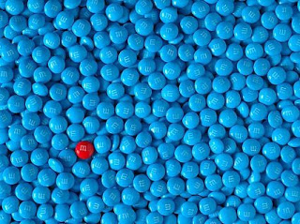

So what’s out of place in reading education?

My nominee is the act of teaching kids to read nonsense words. Don’t do it. It don’t belong (it may even be worse than orange and green).

Why, you might ask, would anyone teach nonsense words? I attribute this all-too-common error to a serious misunderstanding of tests and testing.

Many years ago researchers were interested in determining how well kids could decode. They decided upon lists of words that were graded in difficulty. The more words the students could read accurately, the better we assumed his/her decoding must be.

But, then they started to think: It’s possible for kids to memorize a bunch of words. In fact, with certain high frequency words we tell kids to memorize them. If I flash the word “of” to a student and he/she reads it correctly, that might not be due to better phonics skills, but just because Johnny had that one drilled into long-term memory.

That means with word tests we can never be sure of how well kids can decode.

The solution: nonsense words tests. If we give kids lists of nonsense words, that is combinations of letters that fit English spelling patterns, but that aren’t really words, then if students can read them they must have decoding skills, because no one in their right mind would teach these made up letter combinations to children.

Enter tests like DIBELS decoding measure. Tests designed to help determine quickly who needs more help with decoding. These aren’t tests aimed at evaluating programs or teachers; they are diagnostic.

These tests work pretty well, too. Studies show a high correlation between performance on nonsense words and real words, and some of the time the nonsense word scores are more closely related with reading achievement than the word test scores!

But many schools are now using these to make judgments about teachers.

And, the teachers’ reaction has been to teach nonsense words to the kids. Not just any nonsense words either; the specific nonsense words that show up on DIBELS. That means these teachers are making the test worthless. If kids are memorizing pronunciations for those nonsense words, then the tests no longer can tell how well the kids can decode.

We can do better. Please do not use these kinds of tests to make judgments about teachers, it just encourages foolish responses on their parts. And, please do not teach these nonsense words to the kids. It is harmful to kids. It definitely doesn’t belong here.

