MLPP

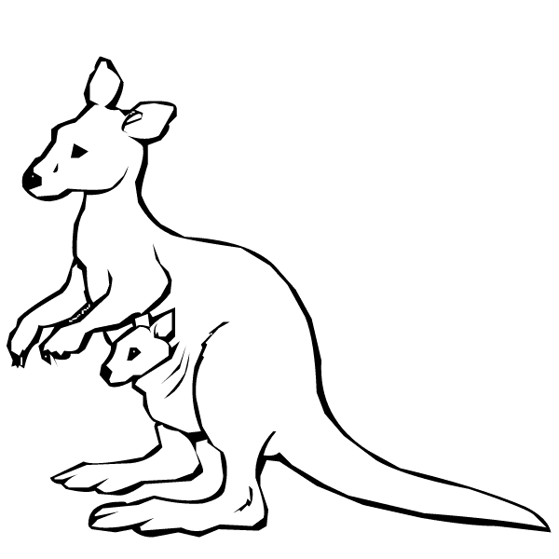
Milestone Assessments

Writing
Oral Language
Comprehension
Oral Reading Fluency
Attitudes and Self-Perception

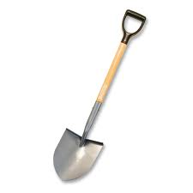
Digging Deeper Assessments

Known Words Activity
Phonemic Awareness
Hearing and Recording Sounds
Concepts of Print
Sight Word/Decodable Word Lists
Letter/Sound ID

