Michigan’s Mission: Literacy
Site Outline
Michigan’s Mission Possible (Site Search, Opportunity to Comment/Request, Introduction, History of Project)
Videos
RLTC History --
Letters of Support

Effective Classroom Instruction
Classroom Discourse (Stanford MOOC – Spring 2016)
Collaborative Conversations – FF; Academic Conversations – JZ
New! Academic Language Development Network
Growth Mindset
New! Student Reflection Log – Marzano
Visible Learning – John Hattie
Teacher and Teaching Influences
Teacher as Architect – Fraser Modern Teacher PD
A Model of Learning Objectives
FIT Teaching – Fisher and Frey (ASCD), links to MI presentation
A Toolkit for High Quality Teaching and Learning
Focusing on Your WHY? (Marvin Jackson video)
Lesson Analysis – EQuIP Rubric
Additional Resources (An Ethic of Excellence; Austin’s Butterfly)

Literacy Tools

Guided Reading (Coaching Readers: Sample Teaching Points by Reading Level)
(Language of a Reading Conference)
(Sight Word Cards, Levels A-J)
Resources developed by Char-Em ISD
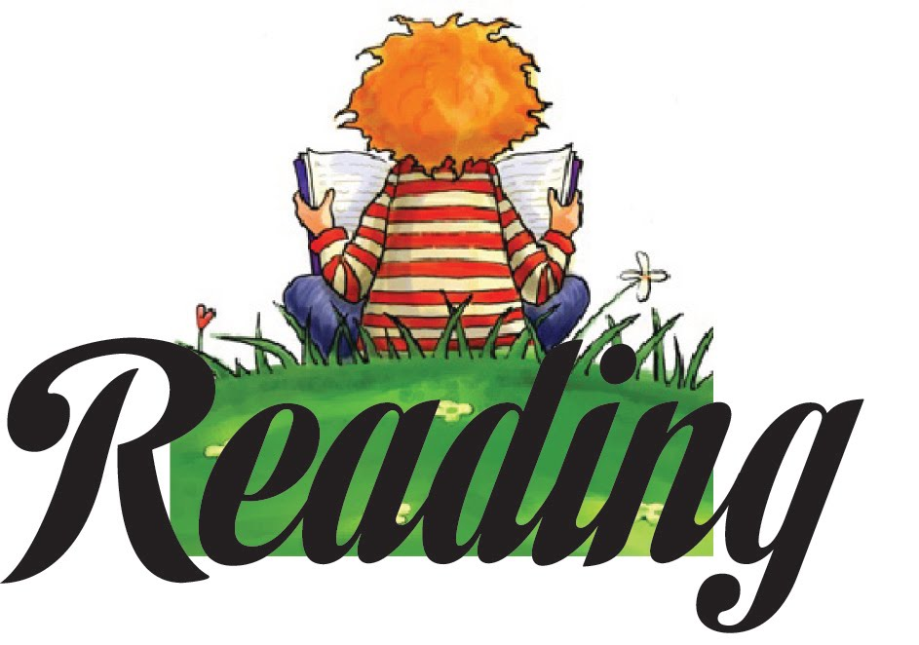
Guided Reading PD Resources developed by COOR ISD

Reading Fluency (Links to Rasinski resources)
Assessment
Strategies

Reading Comprehension
Assessment – Reading Comprehension
Strategies – Reading Comprehension

Close and Critical Reading –
New! Close, Critical, and Generative Reading Flip Book
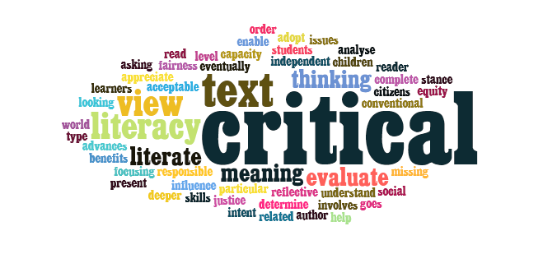
New! Close, Critical, and Generative Reading Rubrics

Notice and Note: Strategies for Close Reading Beers and Probst
Notice and Note: Reading Nonfiction Stances and Signpost

New! Signpost Bookmarks – Narrative and Informational

Close and Critical Reading Examples
Resources from MRA 2015 Session
Finding Texts for CCR
Critical Reading Strategies (Profundity)
Critical Literacy
Critical Thinking
Critical Reading Assessment (lots of older resources here)
Critical Reading Q1
Critical Reading Q2
Critical Reading Q3
Critical Reading Q4
CC Reading PD Module

Reading Research
Poetry
Vocabulary Instruction
Assessment
Recommendations
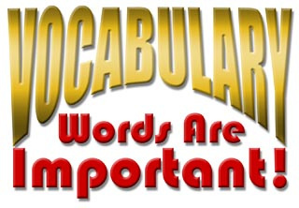
IES Practice Guide
Word Wise
4 Part Vocabulary Program – Graves
Marzano’s Six Steps
Strategies
Resources
Word Selection
Putting It Together
Word Study / Spelling
Assessment
Strategies

Oral Language

Grammar
Grade Level Grammar Mini-lessons embedded within each Grade’s WriteWell resources
Scope and Sequence

Writing Fluency
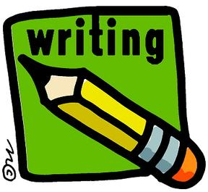
Strategies

Writing Development
Writing Strategies – Swift Pens
Assessment
Using MEAP Released Anchor Sets to Improve Writing
Web Tools

Visual Literacy

Research Recommendations

Technology Resources

Disciplinary Literacy
Literacy in Science (New MSS=NGSS)
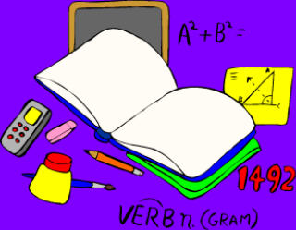
Literacy in Social Studies
Literacy in English Language Arts
Literacy in Mathematics
Content Area Standards
Career and College Ready Michigan
Next Generation Science Standards
NGSS Resources (NSTA infographic on NGSS)
MI Science Standards
CCSS Mathematics

21st Century Skills
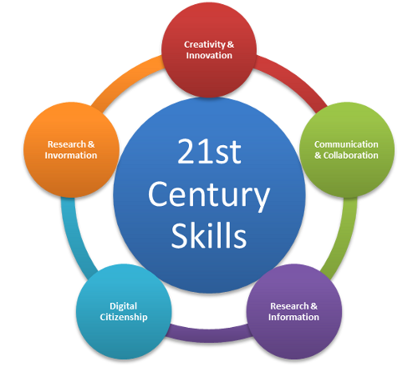
Common Core
Assessment (links to M-Step information)
CCSS-Aligned Assessment
MISD M-STEP Practice Assessments
Assessment Literacy
SBAC English Language Arts / Literacy
SBAC Mathematics

Professional Development
Considerations for Teacher Preparation

Resources
Recommendations – Kelly Gallagher In the Best Interest of Students
Common Core ELA/Literacy Resource Collections
CCSS Exemplars – EquIP
Achieve the Core
Other States
Instructional Resources
Unit Development Resources
HS ELA Model Units Developed for HSCE
EQuIP Rubrics and Exemplars
Resources by Anchor Text / Genre / Theme
Adventures of Huckleberry Finn – Mark Twain
Catcher in the Rye – JD Salinger
Links to Exemplar ELA Teacher Sites
Reading
Complex Text
Guided Highlighted Reading
Informational Text
Author’s Point of View
Resources by CCSS Reading Category
Writing
WriteWell Resources (St. Clair RESA)
Writing Assessment

Speaking and Listening
Academic Discourse
Listening Resources
Language

College and Career Readiness
Academic Moves – Jim Burke, Barry Gilmore

SREB Readiness Courses – Transitioning to College and Career
SREB Making Middle Grades Work – Getting Students Ready for HS Coursework

ACT Resources
ACT Persuasive Essay Writing
ACT WorkKeys Resources
ACT Reports
ACT Aspire

SAT Resources – Links to CB resources SAT Essay Rubrics (Analytic, Holistic, Explicated)

Formative Assessment

Assessment Pathways New! Assessments to Ensure Literacy Competence (DRAFT)

Comprehensive Literacy Plan Birth to 5; Elementary (K-5); Adolescent/Secondary (4-12)

Preschool Plan
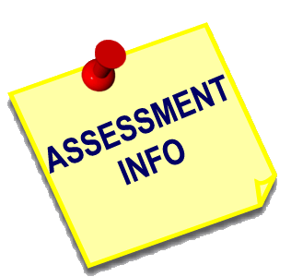
Comp Lit Presentations

Literacy in Action – 7 PD Modules with resources
New! Writing Tracker Hands-On Workbook Resource developed by MISD
S. Graham article – “Writing Makes Middle School Students Better Learners”

Michigan Literacy: The Next Chapter From Michigan Literacy Progress Profile (MLPP) to Mission Literacy: The Next Chapter (ML - TNC) 10 Modules, Ppts., Agenda, Handouts
Resources developed by COOR ISD and COP ESA

Professional Development
Introduction to MP
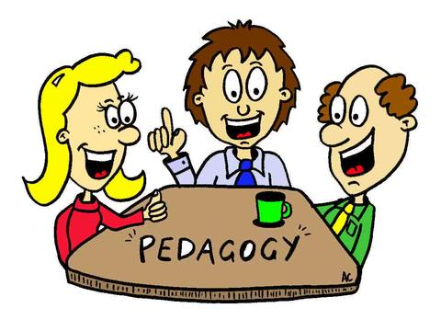
Current Professional Learning Opportunities
PD Resources
Adolescent Literacy AdLit.org
MDE Early Literacy and Mathematics Initiative
Learning Institute
Online Learning Modules
Using Technology
MRA Session Resources
MRA March 2016 – This site map, resources from Mission Literacy presentations
MRA March 2015
MRA Summer 2014
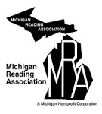
MRA March 2013
MRA Fall 2012
MRA Summer 2012

Policy Recommendations for Literacy Learning

School Improvement (Page Under Development)
High Reliability Schools – Marzano

Student Page

Parent Page – CCSS Resources for Parents

Resources

Mission Literacy 2016 WorkGroup – Elaine Weber, MISD; Sue Kelly, MMP; Carrie Wozniak, Fraser Schools; Barbara Mick, COOR ISD; Patti Loper, Char-Em ISD; Jackie Fry, COP ESD, Pam Ciganick, Char-Em ISD; Victoria Les, St. Clair RESA

