Michigan’s Mission: Literacy
Site Outline
Michigan’s Mission Possible (Site Search, Opportunity to Comment/Request, Introduction, History of Project)
Mission Literacy Promotional Flyer
Videos
RLTC History --
Letters of Support

Effective Classroom Instruction
Essential Instructional Practices in Early Literacy, Pre-K, K-3
Assessments to Ensure Literacy Competence
Balanced Literacy
Growth Mindset (Choice Words, Opening Minds, Mindset)
Student Reflection Log – Marzano
Visible Learning – John Hattie
Teacher and Teaching Influences
Teacher as Architect – Fraser Modern Teacher PD
Focusing on Your WHY? (Marvin Jackson video)
Competency Based Learning
The Power of a Conceptual Lens
FIT Teaching – Fisher and Frey (ASCD), links to MI presentation
A Toolkit for High Quality Teaching and Learning
Lesson Analysis – EQuIP Rubric
Additional Resources (An Ethic of Excellence; Austin’s Butterfly)

Literacy Tools (The Read-Aloud Project)
Research Recommendations
Reading Research
Assessment
Assessments to Ensure Literacy Competence
Managing the Working Parts of Reading
Reading Foundations
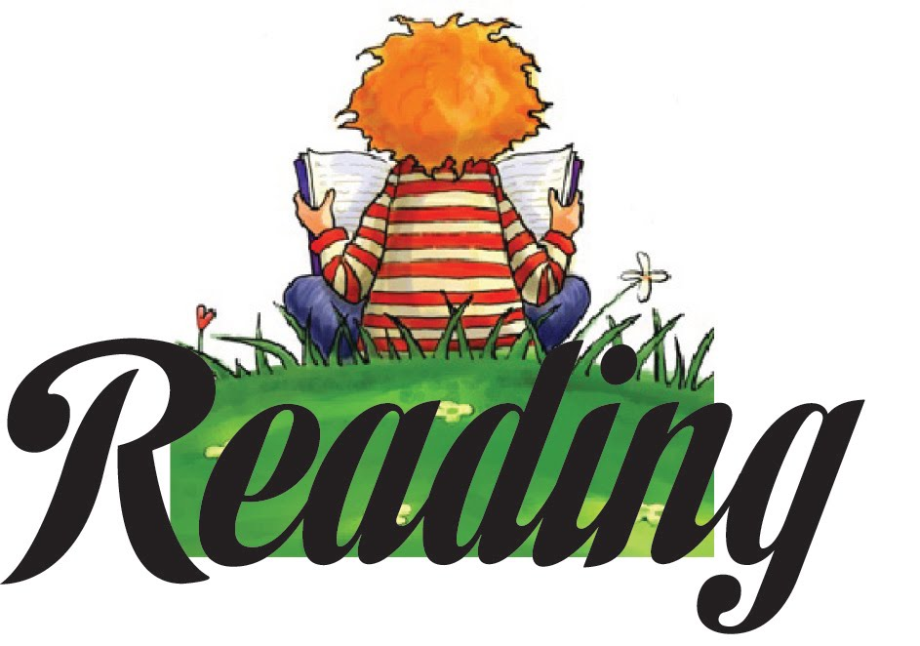
Print Concepts
Phonological Awareness
Knowledge of Alphabet
Word Recognition
(Phonics)
Oral Language (Receptive and Expressive)
Motivation and Engagement
Reading Level
Self-Monitoring
Reading Fluency Assessment
Basic Comprehension
Retelling
Reading Fluency – Links to Rasinski resources
Assessment
Strategies
Close, Critical, Analytical Reading
Deeper Reading – Generative Reading and Application
Close and Critical Reading –
New! Close, Critical, and Generative Reading Flip Book
New! Close, Critical, and Generative Reading Rubrics

Notice and Note: Strategies for Close Reading Beers and Probst
Notice and Note: Reading Nonfiction Stances and Signpost

New! Signpost Bookmarks – Narrative and Informational

Close and Critical Reading Examples
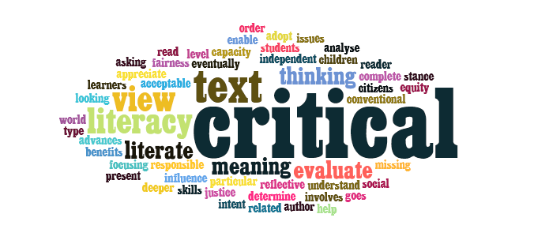
Resources from MRA 2015 Session
Finding Texts for CCR
Critical Reading Strategies (Profundity)
Critical Literacy
Critical Thinking
Reading Comprehension
Close and Critical Reading
Assessment – Reading Comprehension
Strategies – Reading Comprehension (Read Aloud)
Guided Reading (Coaching Readers: Sample Teaching Points by Reading Level)
(Language of a Reading Conference)
(Sight Word Cards, Levels A-J)
Resources developed by Char-Em ISD
Guided Reading PD Resources developed by COOR ISD
Grouping
Word Study - Phonics and Spelling, Vocabulary, Grammar / Word Usage
Spelling Assessment
Word Study Strategies
Vocabulary Instruction
Assessment
Recommendations
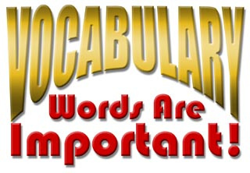
IES Practice Guide – Vocabulary Recommendations
Word Wise
Four-Part Vocabulary Program, Graves
Marzano’s Six Steps
Strategies
Resources
Word Selection
Putting It Together
Grammar / Word Usage
Grade Level Grammar Mini-lessons embedded within each Grade’s WriteWell resources
Scope and Sequence (Developed by St. Clair Co. RESA)
Classroom Discourse (Elaborate, Clarify, Question)
WIDA – Focus on STEM Discourse
Collaborative Conversations – FF; Academic Conversations – JZ
Academic Language Development Network – Constructive Conversation
Writing (Fluency, Focus, Form) Interactive Writing
Writing Fluency
Ingredients of Good Writing
Strategies
Writing Development (Ingredients of Good Writing)
Writing Strategies (SWIFTPENS)
Writing Resources
Assessment
Using MEAP Released Anchor Sets to Improve Writing
Web Tools
Visual Literacy
Technology Resources
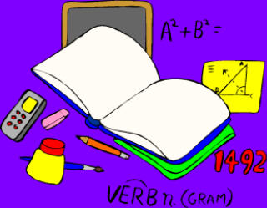

Disciplinary Literacy
Literacy in Science (New MSS=NGSS)
Literacy in Social Studies
Literacy in English Language Arts
Literacy in Mathematics
Content Area Standards
Career and College Ready Michigan
Next Generation Science Standards
NGSS Resources (NSTA infographic on NGSS)
MI Science Standards
CCSS Mathematics

21st Century Skills
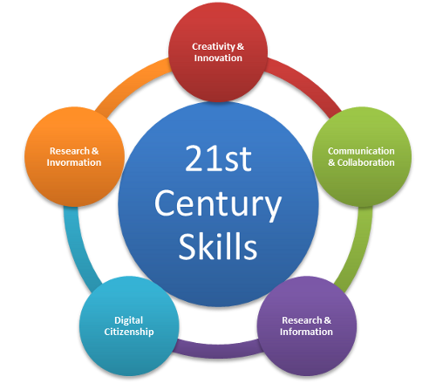
Common Core
Assessment (links to M-Step information)
CCSS-Aligned Assessment
MISD M-STEP Practice Assessments
Assessment Literacy
SBAC English Language Arts / Literacy
SBAC Mathematics

Professional Development
Considerations for Teacher Preparation

Resources
Recommendations – Kelly Gallagher In the Best Interest of Students
Common Core ELA/Literacy Resource Collections
CCSS Exemplars – EQuIP
Achieve the Core
Other States
Instructional Resources
Unit Development Resources
HS ELA Model Units Developed for HSCE
EQuIP Rubrics and Exemplars
Resources by Anchor Text / Genre / Theme
Adventures of Huckleberry Finn – Mark Twain
Catcher in the Rye – JD Salinger
Links to Exemplar ELA Teacher Sites
Reading
Complex Text
Guided Highlighted Reading
Informational Text
Author’s Point of View
Resources by CCSS Reading Category
Writing
WriteWell Resources (St. Clair RESA)
Writing Assessment

Speaking and Listening
Academic Discourse
Listening Resources
Language

College and Career Readiness
Academic Moves – Jim Burke, Barry Gilmore
SREB Readiness Courses – Transitioning to College and Career
SREB Making Middle Grades Work – Getting Students Ready for HS Coursework

ACT Resources
ACT Persuasive Essay Writing
ACT WorkKeys Resources
ACT Reports
ACT Aspire

SAT Resources – Links to CB resources SAT Essay Rubrics (Analytic, Holistic, Explicated)
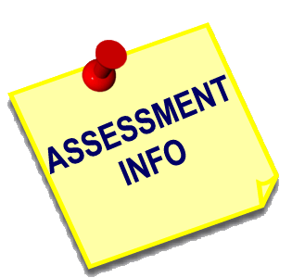
Assessment
New! Assessments to Ensure Literacy Competence (DRAFT)
MLPP Resources
Formative Assessment

Comprehensive Literacy Plan Birth to 5; Elementary (K-5); Adolescent/Secondary (4-12)
Preschool Plan
Comp Lit Presentations

Literacy in Action – 7 PD Modules with resources
Ingredients of Good Writing
Writing Tracker Hands-On Workbook Resource developed by MISD
S. Graham article – “Writing Makes Middle School Students Better Learners”

Michigan Literacy: The Next Chapter
From Michigan Literacy Progress Profile (MLPP) to Mission Literacy: The Next Chapter (ML - TNC)
10 Modules, Ppts., Agenda, Handouts
Resources developed by COOR ISD and COP ESA

Professional Development
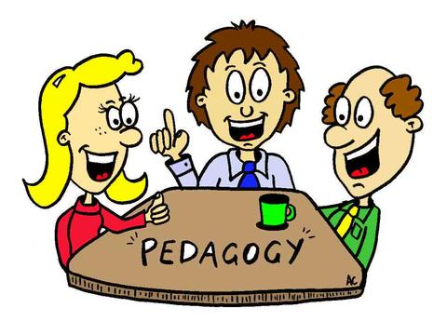
Introduction to MP
Current Professional Learning Opportunities
PD Resources
Adolescent Literacy AdLit.org
MDE Early Literacy and Mathematics Initiative
Learning Institute
Online Learning Modules
Using Technology
MRA Session Resources
MRA March 2017 – This site map, resources from Mission Literacy presentations
MRA March 2012 - 2016
Policy Recommendations for Literacy Learning

School Improvement (Page Under Development)
High Reliability Schools – Marzano

Student Page

Parent Page – CCSS Resources for Parents

Resources

Mission Literacy 2016-17 WorkGroup – Elaine Weber, MISD; Sue Kelly, MMP; Barbara Mick, COOR ISD; Patti Loper, Char-Em ISD; Jackie Fry, COP ESD, Pam Ciganick, Char-Em ISD; Carrie Wozniak, Fraser Schools; Victoria Les, St. Clair RESA

