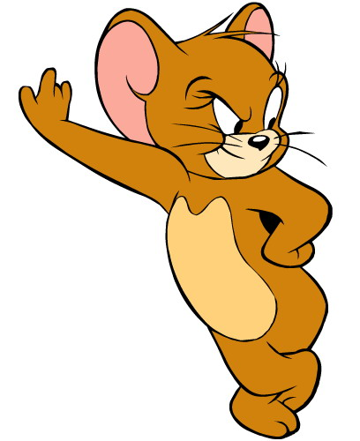
TICKET OUT THE DOOR
11-3-14
3 things I learned tonight that I want to think about more…
2 things that were a little hard for me or I’m not sure about…
1 thing I will try tomorrow…

TICKET OUT THE DOOR
11-3-14
3 things I learned tonight that I want to think about more…
2 things that were a little hard for me or I’m not sure about…
1 thing I will try tomorrow…

