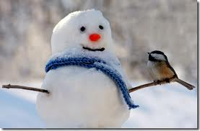
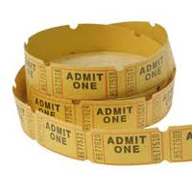
Ticket
Out the Door

3 things I want to remember from tonight | 1.  2.  3.
2 things I’m still not sure about or have a question about | 1.  2.
1 suggestion to make the next session better | 1.

